NEWSLETTER GUIDE: HOW TO ACCOMPLISH A GOOD NEWSLETTER

- A good newsletter should have original and useful information
  - Using the student’s needs cycle, source resources and information that would be helpful and beneficial to students in that month
  - Utilize campus resources such as: Academic Advising, Student Experience Office etc. to seek help in providing useful information for residents

- A good newsletter should be visually appealing
  - Use high resolution pictures
    - There should be a good balance of text and images
  - Use illustrations
  - Use an appealing color scheme
  - Create a header
    - This sits at the very top of the newsletter
    - Should include the newsletter tittle

- A good newsletter should stick to standard fonts
  - Fonts should be legible
  - Avoid using too many fonts in the newsletter
    - This is very disorganized and distracting
  - Pick one or two fonts and stick to it

- A good newsletter should have an organized layout
  - Use subheadings
    - The several pieces of content featured in the newsletter should be broken into sub-headings
    - The font of the sub-headings should be smaller than the header but larger than the text used un the articles.

- A good newsletter should have an interactive component
  - Give a monthly challenge
  - Include takeaways such as: Motivational Quotes, Coloring Page, Goal Tracker, Study Planner etc.

- Personalize your newsletter
  - Include a welcome note in your newsletter. This makes your newsletter come across as friendlier and makes it more likely to be read.
- Be prepared: Create a Content Calendar
  - This is a planning tool that allows you to map out your newsletter content well in advance. Below is an example of what a content calendar looks like:
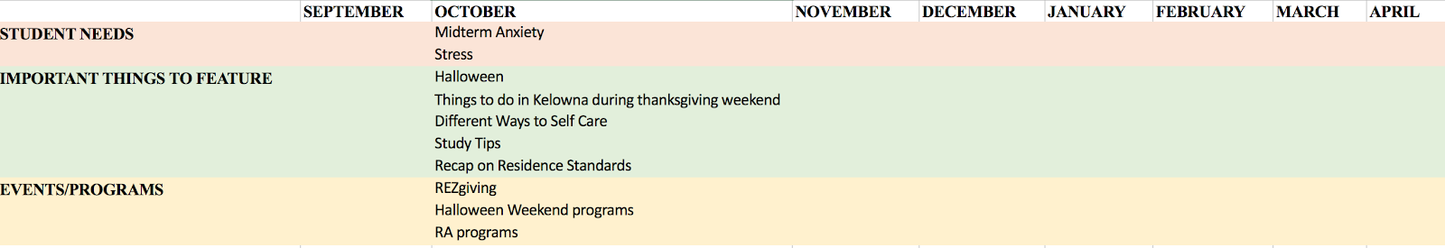

NEWSLETTER GUIDE: NEWSLETTER TIPS

- Use dafont.com or fontspace.com to:
  - Incorporate cool and legible fonts in your newsletter

- Use colourlovers.com to:
  - Get amazing color palette ideas

- Use canva.com to:
  - Create awesome posters, newsletters etc.
  - Get high resolution pictures and illustrations

NEWSLETTER GUIDE: THINGS TO AVOID WHEN MAKING A NEWSLETTER

- Too much content
  - Residents are busy and would not have enough time to read an overly crowded newsletter. Especially if the newsletter appears boring and lacks pictures/illustrations.

- Too little content
  - Your newsletter should include information that is relevant and helpful to residents. It is advisable to create a content calendar or planner so you do not run out of ideas

- Text Proportionality
  - Big chunks of text
  - To avoid this, aim for paragraphs that are about 3-4 sentences
  - Use bulleted lists or numbered lists and headlines

- Poor Design
  - Avoid light text on a dark background
  - Avoid using overly bright colors. Tone them down so they do not compete with your words
  - Use simple designs
  - Poor color combinations
  - Poor contrast with the background

- Rushing to get it done
  - Take your time, do not leave making a newsletter to the very last minute to avoid:
    - Bad typography
    - Grammar error
    - Placeholder text

